3. PROGRAMME TECHNICAL REPORT

- Task Description
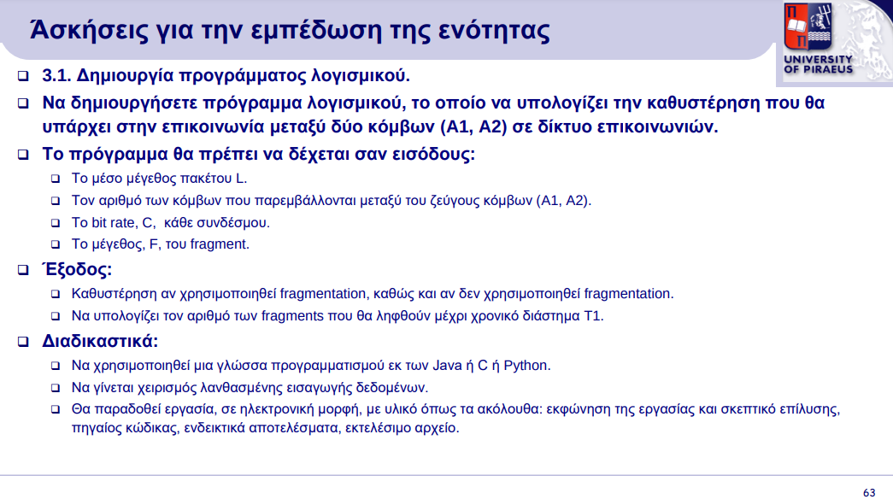
- Input
For the implementation of the software program, the input of data such as: The average packet size (L), header size (H), number of nodes (N) interleaved between the pair of nodes (A1, A2), bit rate (C) and fragment size (F). For each input, the program runs validity checks. More specifically:

- Packet Length(L):

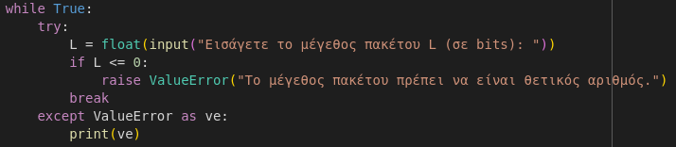
The program allows the insertion of a float which is >0. In any other case, i.e. when a negative number, 0, is entered, the alphanumeric displays an error message.

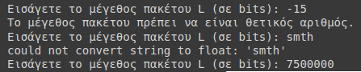
- Header Size (H):
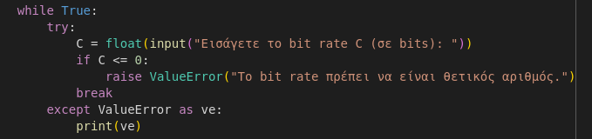
The program, allows the insertion of a float which is >0. In any other case, i.e. when a negative number, 0, is entered, the alphanumeric displays an error message.
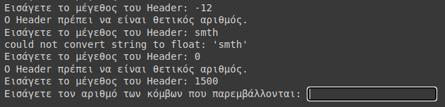

- #Nodes (Ν):
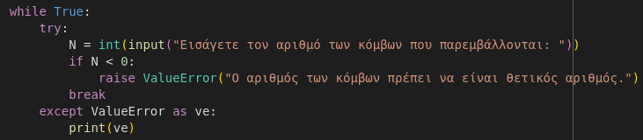
The program allows the input of an integer which is >=0. In any other case, when a negative number or an alphanumeric number is entered, an error message is displayed.
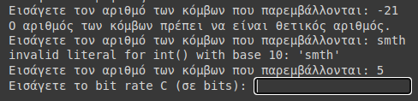
- Bit Rate (C):

The program allows the insertion of a float which is >0. In any other case, i.e. when a negative number, 0, or an alphanumeric is entered, an error message is displayed.
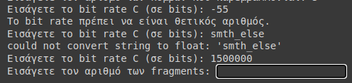

- Fragments (F):
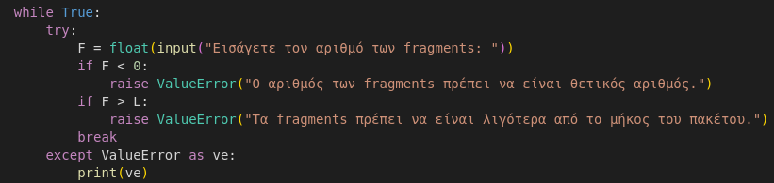
The program, allows the insertion of a float which is >=0. In any other case, an error message is displayed, i.e., when a negative number or an alphanumeric number is entered. In addition, it is checked if the fragments are smaller than the packet size.
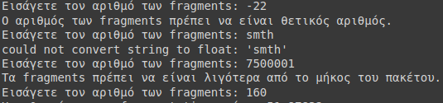

- Output
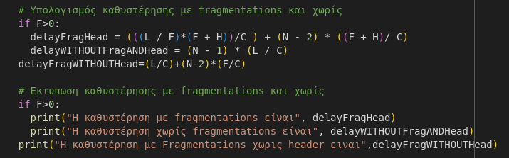
For the output of the system, the delays with fragments and headers, with fragments without headers and without fragments and headers must be calculated. Then, these results are displayed on the user screen. However, when the user enters 0 as fragments, 2 ifs prevent the program from calculating delays with fragment and headers and with fragments without headers to avoid run time errors.

- Sample Output
